Model Uncertainty

1. Introduction: What Is Uncertainty in Statistical Modeling?
Statistical models are used to learn relationships from data and make predictions about populations or future observations. However, a model is never perfectly certain because:
- We usually observe only a sample, not the entire population.
- The sample may be noisy or unrepresentative.
- Model parameters are estimated rather than known exactly.
- Future observations contain random variation.
- The chosen model may not perfectly represent reality.
- Different reasonable samples can produce different fitted models.
Therefore, an important part of statistical modeling is not only asking:
“What is the estimate or prediction?”
but also:
“How uncertain are we about that estimate or prediction?”
For example, suppose a regression model predicts that a house will sell for:
y = $300,000
The value $300,000 alone does not tell us how reliable the prediction is. We might instead report:
$300,000 $250,000-$350,000
The interval communicates uncertainty.

Example of Model Uncertainty
Suppose we want to predict salary from years of experience.
We might consider:

Model 1: Linear
Salary = β0 + β1Experience + ϵ

Model 2: Quadratic
Salary = β0 + β1Experience + β2Experience2 + ϵ

Model 3: Logarithmic
Salary = β0 + β1log(Experience) + ϵ
If the data do not clearly tell us which functional form is correct, we have model-form uncertainty.

2. Sources of Model Uncertainty
Model uncertainty can be divided into several important components.

Sampling uncertainty
We usually study a sample rather than the entire population.
Suppose the population relationship is:
Y = β0 + β1X + ϵ.
One random sample may give:
β^1 = 2.1
while another sample may give:
β^1 = 2.5.
The variation between these estimates is sampling uncertainty.

3. Parameter uncertainty
The parameters of a model are usually unknown and estimated from data.
For example:
Y = β0 + β1X + ϵ
The true values of:
β0 ,β1
are unknown.
We estimate them using:
β^0 , β^1
Different samples produce different estimates.
Therefore, there is uncertainty about the parameter values.

4. Structural or model-form uncertainty
We may not know the correct mathematical form.
For example:
Y = β0 + β1X + ϵ
might be too simple if the true relationship is nonlinear.
Possible alternatives include:
Y = β0 + β1X + β2X2 + ϵ
or
Y = β0 + β1logX + ϵ.
Uncertainty about which structure is correct is called structural uncertainty.

5. Data/Measurement Uncertainty
Data may be uncertain because of:
- sampling error,
- measurement error,
- missing observations,
- inaccurate responses,
- recording errors,
- noisy measurements.
For example:
X_{observed} = X_{true} + measurement error.
Measurement uncertainty can affect parameter estimates and predictions.

6. Aleatoric and Epistemic Uncertainty
A useful distinction is between aleatoric and epistemic uncertainty.

6.1 Aleatoric uncertainty
Aleatoric uncertainty is the inherent randomness or variability in the phenomenon.
For example, even if we know a person’s age, education, and experience, we cannot perfectly predict their income.
This is because individuals differ in ways that may not be included in the model.
In:
Y = f(X) + ϵ,
the error term () represents unexplained/random variation.
Aleatoric uncertainty generally cannot be eliminated simply by collecting more data.

6.2 Epistemic uncertainty
Epistemic uncertainty comes from lack of knowledge.
Examples:
- insufficient data,
- uncertain model parameters,
- uncertain model structure,
- limited observations in a particular region.
More or better data can often reduce epistemic uncertainty.

7. Model Uncertainty vs Prediction Uncertainty
These concepts should not be confused.

Model uncertainty
Uncertainty about the model itself or its parameters.
Examples:
- Is the slope really 2.0?
- Is the relationship linear?
- Which variables should be included?

Prediction uncertainty
Uncertainty about a future or unobserved outcome.
For example:
“What will the income of a new individual with 5 years of experience be?”
Prediction uncertainty generally includes both:
- uncertainty about the estimated regression function, and
- random variation of the new observation.
Therefore prediction intervals are usually wider than confidence intervals for the mean response.

Why Model Uncertainty Matters
Ignoring model uncertainty can lead to:
- overconfident predictions,
- narrow uncertainty intervals,
- incorrect conclusions,
- poor generalization,
- unreliable extrapolation,
- misleading statistical significance.
A good statistical analysis therefore evaluates not just the fitted model but also the uncertainty associated with it.

8. Standard Error
Before discussing confidence and prediction intervals, we need the concept of standard error (SE).
The standard error (SE) measures the sampling variability of an estimator.
For example:
β^​1 ​ =4.5
with:
SE(β^​1​) = 0.6.
means that the estimated slope has sampling variability of approximately 0.4.
A small SE indicates a relatively precise estimate.
A large SE indicates greater uncertainty.

9. Confidence Intervals
A confidence interval (CI) is an interval estimate used to quantify uncertainty about an unknown population parameter.
A general form is:
Estimate ± Critical value × SE
For a large-sample 95% interval under a normal approximation:
θ^ ± 1.96SE(θ^)
For many regression problems, a t-critical value is used instead:
θ^ ± t_{α/2,df}SE(θ^)

10. Example of a Confidence Interval
Suppose:
β^=10
and:
SE(β^)=2.SE
A 95% approximate confidence interval is:
10±1.96(2)
10±3.92
Therefore:
(6.08,13.92)\boxed{(6.08,13.92)}

11. Correct Interpretation of a 95% Confidence Interval
A common mistake is saying:
“There is a 95% probability that the true parameter lies inside this particular interval.”
In the traditional frequentist interpretation, this is not technically correct.
The correct interpretation is:
If we repeatedly collected samples and constructed confidence intervals using the same procedure, approximately 95% of those intervals would contain the true population parameter.
The parameter is treated as fixed; the interval is random across repeated samples.

12. Confidence Interval for a Regression Coefficient
Consider:
Y = β0 + β1X + ϵ.
Suppose:
β^1 = 2.5
and:
SE(β^1) = 0.4.
Then:
95%CI = 2.5 ± 1.96(0.4)
= 2.5 ± 0.784.
Therefore:
95%CI = (1.716,3.284)
This gives a range of plausible values for the population slope under the model and inference procedure.

13. Prediction Intervals
A prediction interval (PI) estimates the range in which a new individual observation is expected to fall.
Suppose:
Y=β0+β1X+ϵ.
We observe:
X=x0
and want to predict a new value:
Ynew.
The prediction interval accounts for:
- uncertainty in estimating the regression function, and
- random variation of the new individual observation.

14. Confidence Interval vs Prediction Interval
This is one of the most important distinctions.
Feature | Confidence Interval | Prediction Interval
What is estimated? | Mean response | Individual future observation
Includes parameter uncertainty? | Yes | Yes
Includes individual random error? | No | Yes
Width | Narrower | Wider
Purpose | Estimate average outcome | Predict new observation
Suppose the predicted average house price is:
$300,000
A confidence interval might be:
$295,000, $305,000
while a prediction interval might be:
$250,000, $350,000
The prediction interval is wider because individual houses vary around the mean.

15. Why Prediction Intervals Are Wider
Suppose a regression predicts the average house price for a particular house size as:
$300,000.
There is uncertainty about the estimated average price.
But individual houses also differ from that average.
Therefore:
Prediction uncertainty = mean estimation uncertainty + individual random variation.
Hence:
PI > CI
in width for the same confidence level and predictor value.
Formula for a Confidence Interval
For:
Y = β0 + β1X + ϵ
the fitted value at x0x_0 is:
y^0 = b0 + b1x₀.
The standard error of the estimated mean response is:
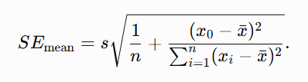
Therefore:
CI = y^​0 ​± t_{α/2,n−2}​SE_{mean​​}
Formula for a Prediction Interval
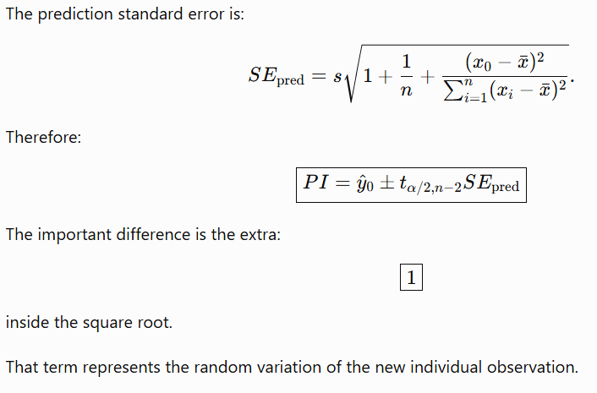
17. Effect of (x_0) on Uncertainty
Prediction and confidence intervals are generally narrower near:
[ x_0={x} ]
and wider when (x_0) is far from the mean predictor value.
This happens because predictions become less certain when we move into regions where there are fewer observations.
This is particularly important for extrapolation.

18. Interpolation vs Extrapolation

Interpolation
Prediction within the observed range of X.
Example:
Observed X:
10,20,30,40,50
Predicting at:
X = 35
is interpolation.

Extrapolation
Prediction outside the observed range.
Predicting at:
X=100
is extrapolation.
Extrapolation is dangerous because the relationship observed in the sample may not continue beyond the observed range.

19. Bootstrap Uncertainty

23.1 Definition
The bootstrap is a computational resampling method for estimating the sampling distribution and uncertainty of a statistic.
It is especially useful when:
- analytical formulas are difficult,
- the statistic is complicated,
- the sampling distribution is unknown,
- the data are non-normal,
- the estimator is nonlinear.

Basic Bootstrap Idea
Suppose the observed dataset is:
D = {x1,x2,…,xn}.
The bootstrap treats the observed sample as an approximation to the population.
We repeatedly draw samples of size nn with replacement from the original sample.
Each resampled dataset is called a bootstrap sample.

20. Why Sampling With Replacement?
Suppose the original sample is:
[ {2,4,5,8,10} ]
A bootstrap sample could be:
[ {4,4,8,10,2} ]
Another could be:
[ {5,5,5,8,10} ]
Because sampling is with replacement:
- some observations may appear multiple times,
- some observations may not appear at all.
Each bootstrap sample represents a possible sample from the estimated population.

21. Bootstrap Algorithm
Suppose we want uncertainty for statistic:
θ^ = T(D).

Step 1
Start with the original dataset:
D.D

Step 2
Randomly sample nn observations with replacement.

Step 3
Calculate the statistic:
θ^∗.

Step 4
Repeat the process many times.
For example:
B=5,000
bootstrap repetitions.

Step 5
Obtain:
θ^1∗,θ^2∗,…,θ^B∗.

Step 6
Use these values to estimate:
- standard error,
- bias,
- confidence intervals,
- sampling variability.

22. Bootstrap Standard Error
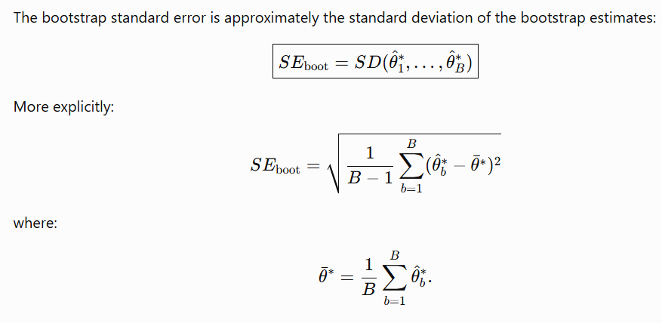

23. Bootstrap Confidence Intervals
There are several important bootstrap confidence interval methods.

23.1 Percentile bootstrap interval
For a 95% bootstrap confidence interval:
- Generate many bootstrap estimates.
- Sort them.
- Take the 2.5th percentile.
- Take the 97.5th percentile.
Thus:
CI95% = [q0.025∗,q0.975∗]
This is simple and intuitive.

24. Basic Bootstrap Interval
Suppose:
- original estimate = θ^\hat{\theta},
- bootstrap lower percentile = L∗L^*,
- bootstrap upper percentile = U∗U^*.
The basic bootstrap interval is:
[2θ^−U∗,2θ^−L∗]​

25. Bootstrap (t) Interval
A bootstrap tt-statistic can be defined as:
t∗ = θ^∗−θ^ / SE∗(θ^)..
The distribution of these statistics can be used to construct a confidence interval.
This can be more sophisticated but requires estimating a standard error for each bootstrap sample.

26. BCa Bootstrap
BCa means:
Bias-Corrected and Accelerated.
The BCa interval adjusts for:
- bias in the bootstrap distribution,
- skewness or acceleration of the statistic’s sampling distribution.
BCa intervals are often preferred when the bootstrap distribution is asymmetric.

27. Bootstrap Example
Suppose a sample contains the ages:
[ 20,22,25,30,35 ]
We want to estimate the median.
The sample median is:
[ 25 ]
We repeatedly resample five observations with replacement and calculate the median each time.
After 5,000 repetitions, suppose the bootstrap distribution has:
[ 2.5% =22 ]
and:
[ 97.5% =30 ]
Then the approximate 95% percentile bootstrap confidence interval is:
[ (22,30) ]
This gives an empirical estimate of uncertainty in the sample median.

28. Bootstrap for Regression
Bootstrap can be used to estimate uncertainty for regression coefficients.
Suppose:
Y=β0+β1X+ϵ.
We can:
- Resample observations.
- Fit the regression to the resampled data.
- Record β^1∗\hat{\beta}_1^*.
- Repeat thousands of times.
- Analyze the resulting bootstrap slopes.
The bootstrap distribution of:
β^1∗
shows how much the slope changes across resampled datasets.

29. Bootstrap Regression Example
Suppose the original slope is:
[ _1=3.2 ]
After 5,000 bootstrap repetitions, the bootstrap slopes range approximately from:
[ 2.1 4.4 ]
If the 2.5th and 97.5th percentiles are:
[ 2.2, ]
then:
[ CI_{95%}=(2.2,4.3) ]
for the regression slope using the percentile bootstrap method.

30. Bootstrap Methods for Regression
Several resampling approaches are possible.

30.1 Pairs bootstrap
Resample complete observations:
[ (X_i,Y_i) ]
as pairs.
This is often useful when we do not want to impose a strong distributional assumption on the errors.

30.2 Residual bootstrap
- Fit the regression model.
- Calculate residuals.
- Resample residuals.
- Add resampled residuals to fitted values.
- Refit the model.
This preserves the predictor values while resampling the error structure.
It is especially useful when the regression assumptions are reasonably appropriate.

31. Advantages of Bootstrap
Bootstrap is useful because:
- it is conceptually simple,
- it can be applied to complicated statistics,
- it does not always require a closed-form sampling distribution,
- it can handle statistics such as medians and quantiles,
- it can estimate uncertainty for complex estimators,
- it is widely applicable.

32. Limitations of Bootstrap
Bootstrap is not magic.
It can perform poorly when:
- the sample size is very small,
- the sample is not representative,
- the data are strongly dependent but independence is assumed,
- extreme values are poorly represented,
- the statistic has unusual sampling behavior,
- the data contain rare events that are absent from the sample.
The bootstrap cannot recover information that is not present in the original dataset.
A useful principle is:
Bootstrap reproduces the information in the sample; it does not create new information about the population.

33. Bootstrap for Dependent Data
Ordinary bootstrap assumes observations are exchangeable/independently resampled in the relevant setup.
For dependent data such as time series, ordinary bootstrap may destroy important dependence.
Examples include:
- stock prices,
- temperature measurements,
- repeated measurements,
- spatial observations.
Special methods may be required, such as:
- block bootstrap,
- moving block bootstrap,
- stationary bootstrap,
- cluster bootstrap.

35. Quantile Regression
Ordinary least squares regression focuses on the conditional mean of (Y).
The model is:
[ E(Y|X=x) ]
Quantile regression instead models a chosen conditional quantile of (Y).
Examples:
- 10th percentile,
- 25th percentile,
- 50th percentile,
- 75th percentile,
- 90th percentile.
Important Principle of Bootstrap
A crucial statement is:
Bootstrap cannot create information that is absent from the original sample
If the sample is poor, the bootstrap may produce a very precise-looking but misleading answer.

Quantile Regression

42.1 Definition
Quantile regression is a regression method that models a specified conditional quantile of the response variable rather than only its conditional mean.
Ordinary least squares focuses on:
E(Y∣X).E(Y|X).
Quantile regression focuses on:
QY(τ∣X)\boxed{ Q_Y(\tau|X) }
where:
0<τ<1.

36. What Is a Quantile?
A quantile divides a distribution into proportions.
For example:

50th percentile
The median.
Approximately 50% of observations are below it.

90th percentile
A value below which approximately 90% of observations fall.

10th percentile
A value below which approximately 10% of observations fall.

37. Ordinary Least Squares vs Quantile Regression
Ordinary least squares estimates:
E(Y∣X=x)
Quantile regression estimates:
QY(τ∣X=x)
For example:
τ=0.5
models the conditional median.
τ=0.9
models the conditional 90th percentile.

38. Quantile Regression Model
For a linear model:
QY(τ∣X)=β0(τ)+β1(τ)X
Notice that the coefficients depend on τ\tau.
Therefore:
β1(0.10)
may differ from:
β1(0.50)
and:
β1(0.90).
This allows the effect of XX to vary across the outcome distribution.

39. Why Use Quantile Regression?
Suppose we study income as a function of education.
OLS might show:
[ =30,000+5,000() ]
This describes the average relationship.
But perhaps education affects different income groups differently.
For example:

10th percentile
[ Q_{0.10}(Y|X)=15,000+2,000X ]

50th percentile
[ Q_{0.50}(Y|X)=30,000+4,000X ]

90th percentile
[ Q_{0.90}(Y|X)=50,000+8,000X ]
This tells us that education has a stronger relationship with high-income outcomes than low-income outcomes.
OLS alone would hide this variation.40. Quantile Regression Objective Function
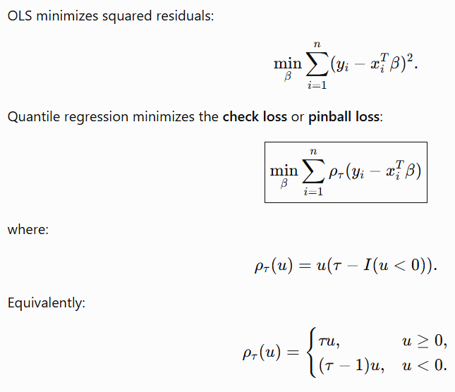

41. Why Is the Loss Asymmetric?
Quantile regression needs an asymmetric loss because different quantiles emphasize different portions of the distribution.
For example, a 90th-percentile regression should position the fitted line so that approximately 90% of the conditional distribution is below the fitted conditional quantile.
At:
τ=0.5
the loss becomes symmetric, corresponding to median regression.

Interpretation of Quantile Regression Coefficients
Suppose:
QY(0.75∣X)=20+3X
The coefficient:
33
means:
Holding other predictors constant, a one-unit increase in X is associated with a 3-unit increase in the conditional 75th percentile of Y.
It does not mean that every individual's outcome increases by 3.
It describes the conditional 75th percentile.

Quantile Regression Can Reveal Heterogeneous Effects
Suppose the estimated slopes are:
Quantile | Slope
0.10 | 1.0
0.25 | 1.5
0.50 | 2.0
0.75 | 3.0
0.90 | 4.0
The effect of (X) becomes stronger as we move toward the upper tail.
This is called heterogeneity across the conditional distribution.
OLS might provide only one slope, perhaps around:
[ 2.3 ]
which would hide this pattern.

Quantile Regression and Skewed Data
Many real-world variables are skewed.
Examples:
- income,
- house prices,
- medical costs,
- insurance claims,
- financial losses.
The mean can be strongly influenced by extreme values.
Quantile regression allows us to examine the median and other percentiles directly.

45. Quantile Regression and Outliers
Quantile regression can be more robust to extreme values than ordinary least squares, especially for central quantiles such as the median.
OLS uses squared residuals:
e_{i}²​.
so large residuals receive disproportionately large weight.
Quantile regression uses absolute/asymmetric loss, making it less sensitive to extreme observations in many situations.
However, quantile regression is not completely immune to outliers.

46. Quantile Regression Does Not Require Normal Errors
Ordinary least squares inference often uses normality assumptions for small-sample exact inference.
Quantile regression does not require the conditional outcome distribution to be normal.
This is a major advantage when:
- distributions are skewed,
- outcomes have heavy tails,
- the variance changes with predictors,
- effects differ across the outcome distribution.

49. Quantile Regression and Prediction
Suppose we want to predict house price.
Instead of giving only:
Y^=400,000
we can estimate:
Q0.10=330,000,
Q0.50=400,000,
Q0.90=480,000.
Now we have information about the conditional distribution.
For example:
The predicted median price is $400,000, while the predicted 10th and 90th conditional percentiles are $330,000 and $480,000.

50. Quantile Regression as an Alternative to Prediction Intervals
If we estimate lower and upper conditional quantiles such as:
Q0.05(Y∣X)
and:
Q0.95(Y∣X)
we can form an approximate 90% conditional prediction range:
Q0.05(Y∣X),Q0.95(Y∣X)
This can be particularly useful when the conditional distribution is:
- asymmetric,
- heteroscedastic,
- non-normal.

51. Quantile Regression vs Ordinary Regression
Feature | OLS | Quantile Regression
Main target | Conditional mean | Conditional quantile
Loss | Squared error | Check/pinball loss
Distribution assumption | Often useful for inference | No normality requirement
Handles skewness | Less naturally | Very well
Handles heteroscedasticity | Limited | Very useful
Outlier sensitivity | High | Generally lower
Describes distribution | Mainly mean | Multiple points of distribution
Coefficients | Usually one set | Can vary by quantile
Example | Average salary | 10th/50th/90th percentile salary

52. Relationship Between Confidence Intervals, Prediction Intervals, and Quantile Regression
These concepts answer different questions.

Confidence interval
How uncertain are we about a population parameter or mean response?

Prediction interval
Where is a new individual observation likely to fall?

Quantile regression
How does a predictor affect different points of the conditional outcome distribution?

Bootstrap
How can we estimate the uncertainty of an estimator when theoretical formulas are difficult or unreliable?

53. A Unified Example
Suppose we predict house prices from house size.
The model is:
Price=β0+β1Size+ϵ.Price=\beta_0+\beta_1Size+\epsilon.
For a 2,000-square-foot house, suppose:
Price^=$400,000.\hat{Price}=\$400,000.

Confidence interval
Suppose:
95%CI=($390,000,$410,000).95\%CI=(\$390,000,\$410,000).
This describes uncertainty about the mean price at that size.

Prediction interval
Suppose:
95%PI=($320,000,$480,000).95\%PI=(\$320,000,\$480,000).
This describes uncertainty about the price of an individual future house.
It is wider because individual houses differ.

Bootstrap
We repeatedly resample the observed houses, refit the regression, and calculate the predicted price.
The resulting bootstrap distribution shows how the prediction changes across resampled datasets.

Quantile regression
We might estimate:
- Q0.10=$320,000
- Q0.50=$400,000
- Q0.90=$480,000.
This describes different parts of the conditional price distribution.

Relationship Between the Concepts
The overall picture can be represented as:
Data→Model→Estimation→Uncertainty→Prediction\boxed{ \text{Data} \rightarrow \text{Model} \rightarrow \text{Estimation} \rightarrow \text{Uncertainty} \rightarrow \text{Prediction} }

Model uncertainty
Concerns whether the model and its parameters are appropriate.

Confidence interval
Quantifies uncertainty about parameters or mean responses.

Prediction interval
Quantifies uncertainty about individual future observations.

Bootstrap
Provides a resampling-based way to estimate sampling uncertainty.

Quantile regression
Describes relationships at different points of the conditional outcome distribution.

Important Assumptions for Classical Regression Intervals
Classical regression confidence and prediction intervals depend on assumptions.
Important considerations include:

1. Linearity
The conditional mean should be appropriately represented by the model.

2. Independence
Observations should be independent under the relevant sampling design/model.

3. Constant variance
For standard linear-model inference, the residual variance is often assumed constant:
Var(ϵ∣X)=σ2.Var(\epsilon|X)=\sigma^2.

4. Normality
Normal residuals are especially important for exact small-sample tt-based inference and prediction intervals.

5. Correct model specification
Relevant variables, transformations, and interactions should be appropriately represented.
Violations can make classical intervals misleading.

67. What Happens When Assumptions Fail?
If assumptions are seriously violated:
- standard errors may be wrong,
- confidence intervals may be too narrow or too wide,
- prediction intervals may be inaccurate,
- p-values may be misleading.
Possible responses include:
- transforming variables,
- robust standard errors,
- bootstrap methods,
- generalized models,
- quantile regression,
- better model specification.
The appropriate solution depends on the specific violation.

55. Sources of Uncertainty in Regression
When using regression, consider:

1. Coefficient uncertainty
How precisely are (_0,_1,) estimated?

2. Residual uncertainty
How much unexplained variation remains?

3. Predictor uncertainty
Are the future (X) values known exactly?

4. Model-form uncertainty
Is the functional form correct?

5. Variable-selection uncertainty
Should another variable be included?

6. Extrapolation uncertainty
Are we predicting outside the observed data range?

7. Measurement uncertainty
Are (X) and (Y) measured accurately?

58. Factors Affecting Interval Width
Intervals become wider when:
- sample size decreases,
- variability increases,
- confidence level increases,
- prediction is far from the center of the data,
- the model is poorly estimated.
Intervals become narrower when:
- sample size increases,
- residual variability decreases,
- the predictor value lies in a well-supported region of the data,
- the confidence level is reduced.

61. Statistical Significance vs Practical Significance
A very narrow confidence interval around a tiny effect may be statistically significant but practically unimportant.
For example:
[ ]
with:
[ CI=(0.0005,0.0015) ]
could be statistically significant in a very large dataset.
The correct question is not only:
“Is the effect statistically different from zero?”
but also:
“Is the effect large enough to matter?”

62. Common Mistakes

Mistake 1: Treating a confidence interval as a probability statement about the parameter
Incorrect:
There is a 95% probability that the parameter is in this interval.
Better:
The procedure used to construct the interval has 95% coverage in repeated sampling under its assumptions.

Mistake 2: Confusing confidence and prediction intervals
A confidence interval is about a population mean/parameter.
A prediction interval is about an individual future observation.

Mistake 3: Assuming prediction intervals are narrow
Individual observations contain random variability, so prediction intervals are generally wider.

Mistake 4: Assuming bootstrap always solves everything
Bootstrap depends on the sample being reasonably representative of the population and on an appropriate resampling scheme.

Mistake 5: Assuming quantile regression predicts the mean
Quantile regression predicts:
[ Q_Y(|X) ]
not:
[ E(Y|X) ]
unless the relevant relationship happens to coincide.

Mistake 6: Assuming one quantile is enough
Analyzing only the median may hide important behavior in the tails.
Often it is useful to examine several quantiles such as:
[ 0.10,;0.25,;0.50,;0.75,;0.90 ]

Mistake 7: Ignoring extrapolation
Even a model with excellent fit can make unreliable predictions outside the observed predictor range.

Ways to Communicate Model Uncertainty
Good statistical communication should avoid reporting only:
Y^=100
Instead, report information such as:
Y^=100, 95%PI=[80,125]
or:
Q_{0.10} = 80, Q_{0.50} = 100, Q_{0.90} = 125
This gives the reader information about uncertainty and variability.

Practical Workflow
A useful workflow is:

Step 1: Understand the data
Check:
- sample size,
- missing values,
- outliers,
- distribution,
- dependence.

Step 2: Specify a reasonable model
Choose:
- response variable,
- predictors,
- functional form,
- interactions.

Step 3: Fit the model
Estimate:
β^.\hat{\beta}.

Step 4: Quantify parameter uncertainty
Use:
- standard errors,
- confidence intervals,
- bootstrap intervals.

Step 5: Quantify predictive uncertainty
Use:
- prediction intervals,
- predictive distributions,
- quantile regression.

Step 6: Check assumptions
Assess:
- residual behavior,
- heteroscedasticity,
- independence,
- nonlinearity,
- influential observations.

Step 7: Consider model uncertainty
Check whether conclusions change under reasonable alternative models.

When to Use Each Method
Situation | Useful method
Estimate uncertainty of a regression coefficient | Confidence interval
Estimate uncertainty of a population mean | Confidence interval
Predict a new individual observation | Prediction interval
Complex/nonlinear statistic | Bootstrap
Median uncertainty | Bootstrap or quantile methods
Skewed outcome | Quantile regression
Heteroscedastic outcome | Quantile regression
Effects differ across outcome distribution | Quantile regression
Unknown/complex sampling distribution | Bootstrap
Uncertainty about model structure | Model comparison/sensitivity/model averaging approaches

67. Comparison of the Four Main Concepts
Concept | Main Question | Main Output
Model uncertainty | How uncertain are we about the model/parameters? | SEs, intervals, sensitivity analyses
Confidence interval | What values are plausible for a population parameter/mean response? | Parameter/mean-response interval
Prediction interval | Where might a new observation fall? | Future-observation interval
Bootstrap uncertainty | What is the empirical sampling variability of an estimator? | Bootstrap distribution, SE, CI
Quantile regression | How does (X) affect different parts of (Y)’s distribution? | Conditional quantile curves

Advantages and Limitations Summary

Confidence intervals

Advantages
- Easy to communicate.
- Standard statistical procedure.
- Quantifies parameter uncertainty.

Limitations
- Depend on assumptions and sampling design.
- Can be misinterpreted.
- Do not automatically account for all model uncertainty.

Prediction intervals

Advantages
- Directly useful for prediction.
- Include individual-level variability.
- More informative than point predictions.

Limitations
- Usually wider.
- Sensitive to model assumptions.
- Can be unreliable for extrapolation.
- Do not automatically account for model-selection uncertainty.

Bootstrap

Advantages
- Flexible.
- Computationally simple conceptually.
- Useful for complicated estimators.
- Can handle skewed/non-normal sampling distributions.

Limitations
- Requires an adequate original sample.
- Can fail with very small samples.
- Ordinary bootstrap is inappropriate for many dependent-data settings.
- Computationally expensive for complicated models.

Quantile regression

Advantages
- Models different parts of the outcome distribution.
- Useful for skewed data.
- Useful under heteroscedasticity.
- Can reveal heterogeneous effects.
- Does not focus only on the mean.

Limitations
- More complex to interpret.
- Requires choosing quantiles.
- Quantile crossing can occur.
- Tail quantiles may require substantial data.
- Model uncertainty still exists.

